**AWS Load Balancer**

Load Balancer are used to distribute the traffic equally across multiple servers.

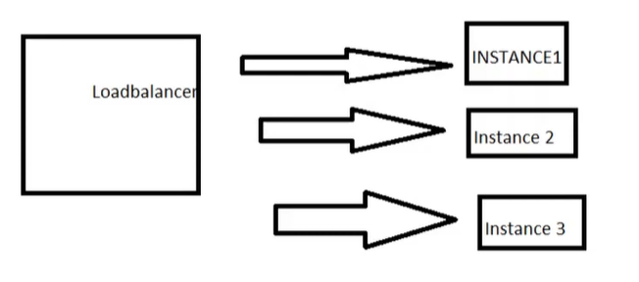

If the server is receiving 300 request the load balancer will equally distribute the load to three instances each 100.

The load balancer will do regular health checkup.

Steps:

1. Create an AWS EC2 instance

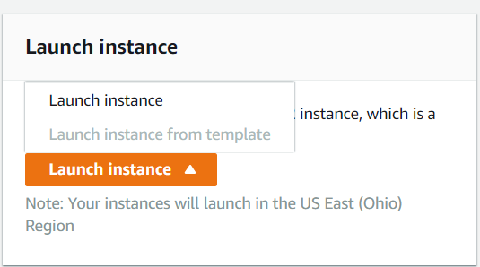

1. Choose windows OS for AMI

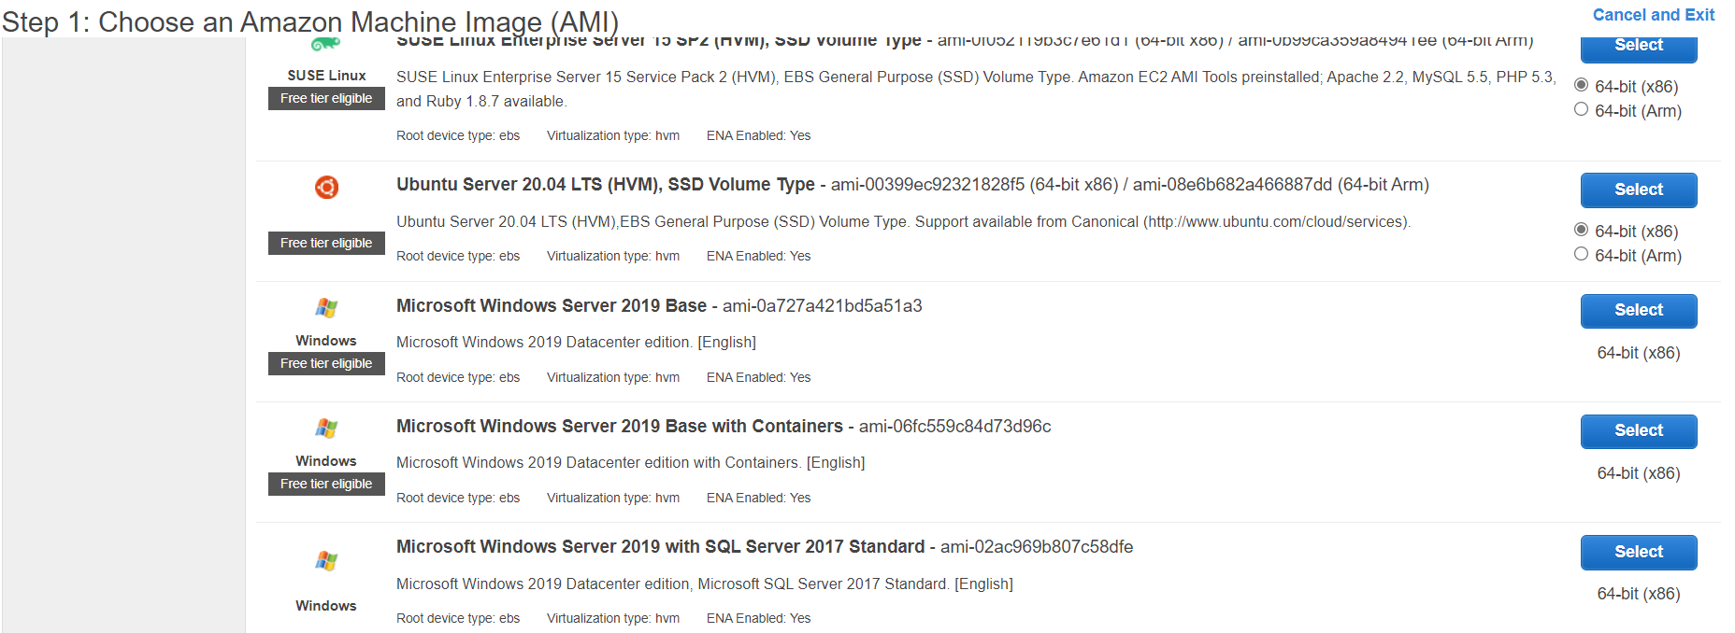

1. Choose free tier instance type

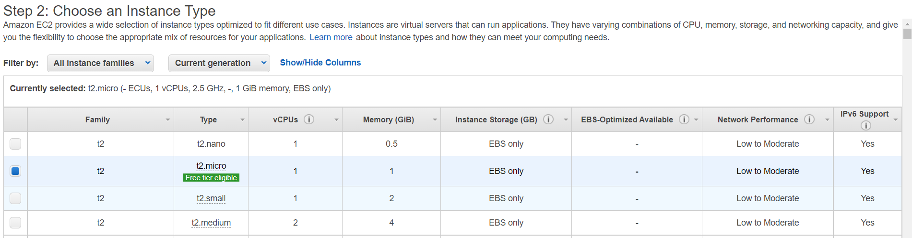

1. Configure Instance details

Number of instances 🡪 2

Network🡪 my_vpc_cloud

Subnet 🡪 my_public_1|us-east-2a

Auto assign public IP 🡪 Enable

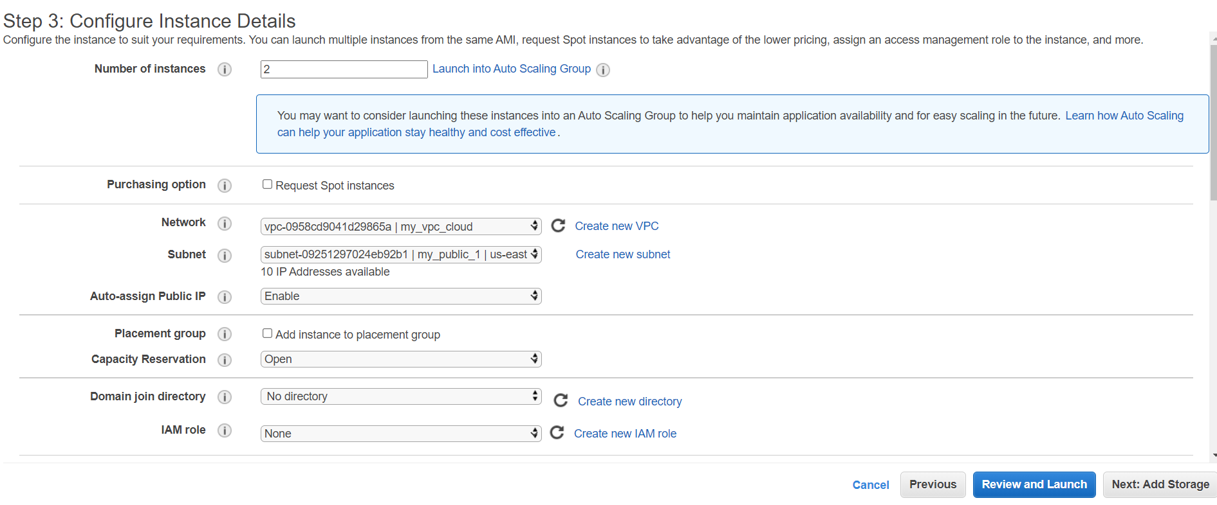

1. Add storage – leave its as default
2. Add tag

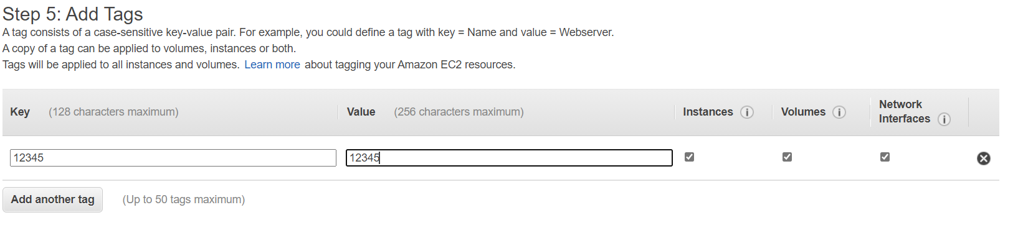

1. Configure security group is like a firewall rule

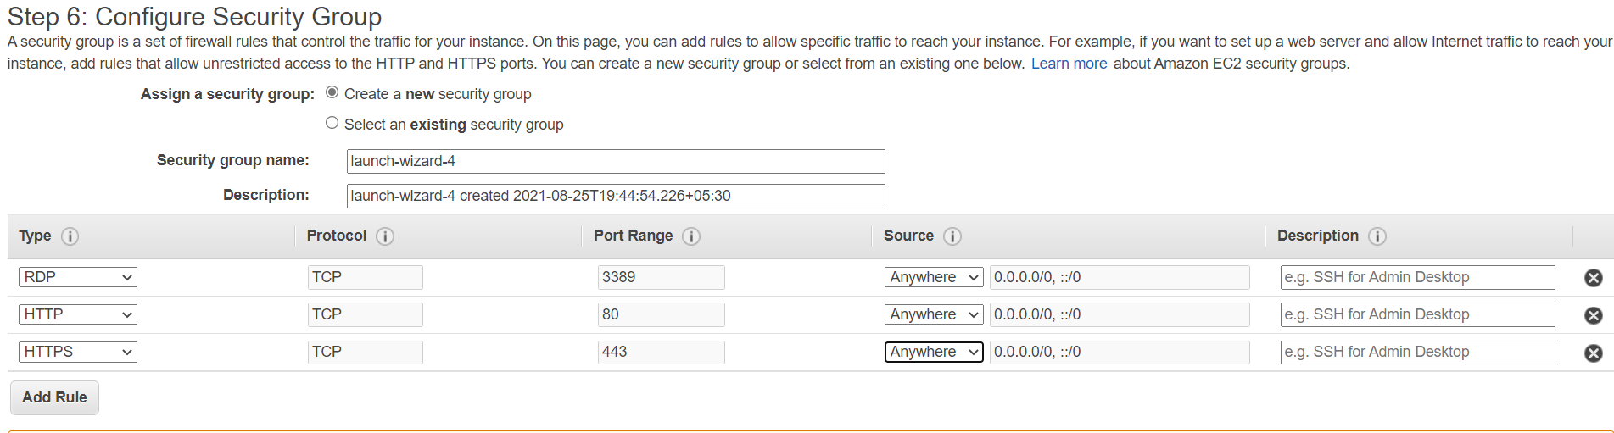

1. Download the key pair and launch the instances

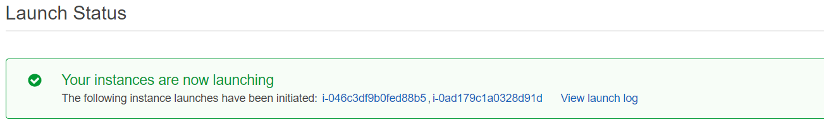

1. Name the instances as I1 and I2

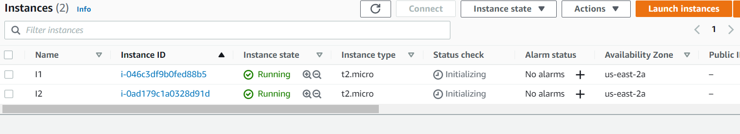

1. Next we will create an elastic IP

Elastic IP is like a static IP*, (when we restart or shut down the server the public ip will be changed, to avoid that we are using elastic ip – It will keep the public ip static)*

Click on Elastic IP

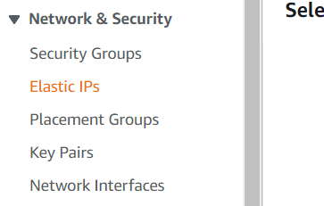

1. Click on “Associate Elastic IP address”.

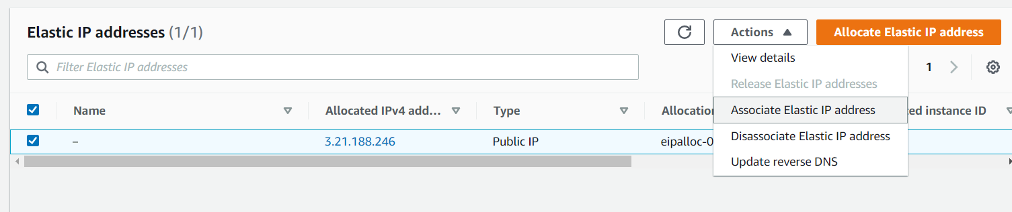

1. Allocate elastic IP address

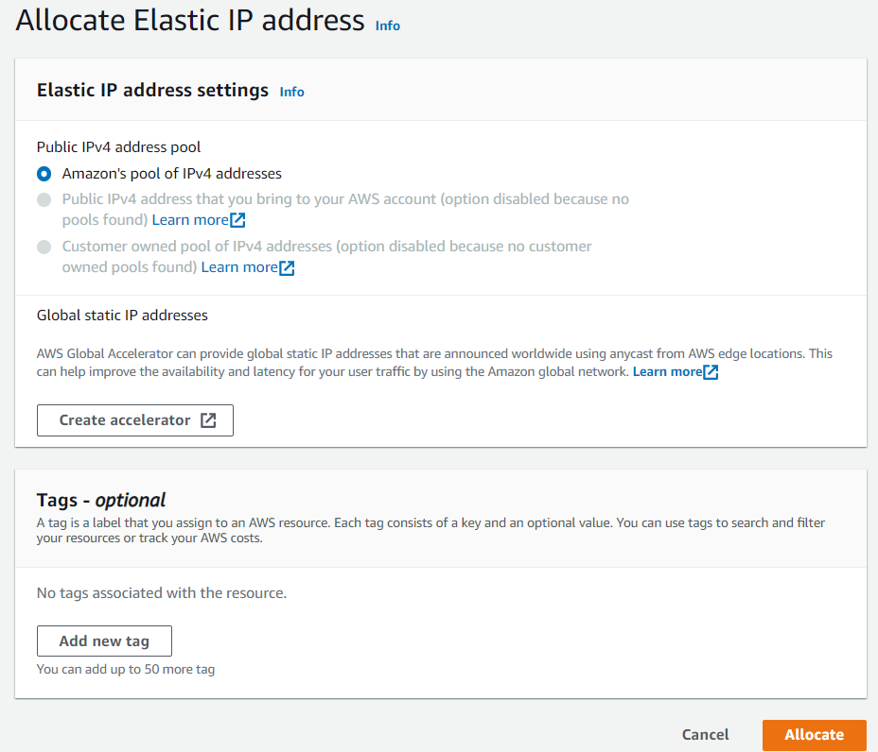

1. New elastic IP has been allocated

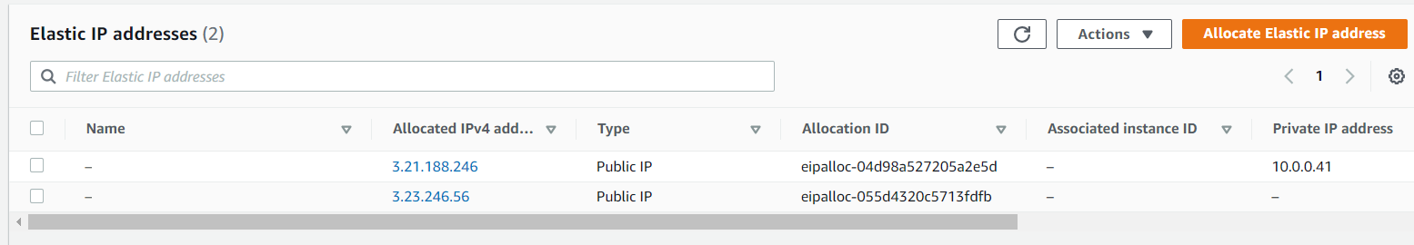

Choose one and click associate elastic Ip address

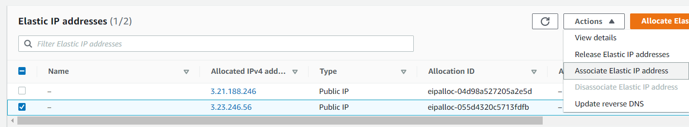

1. Instance🡪select I1 instance

Check in reassociation.

Click associate.

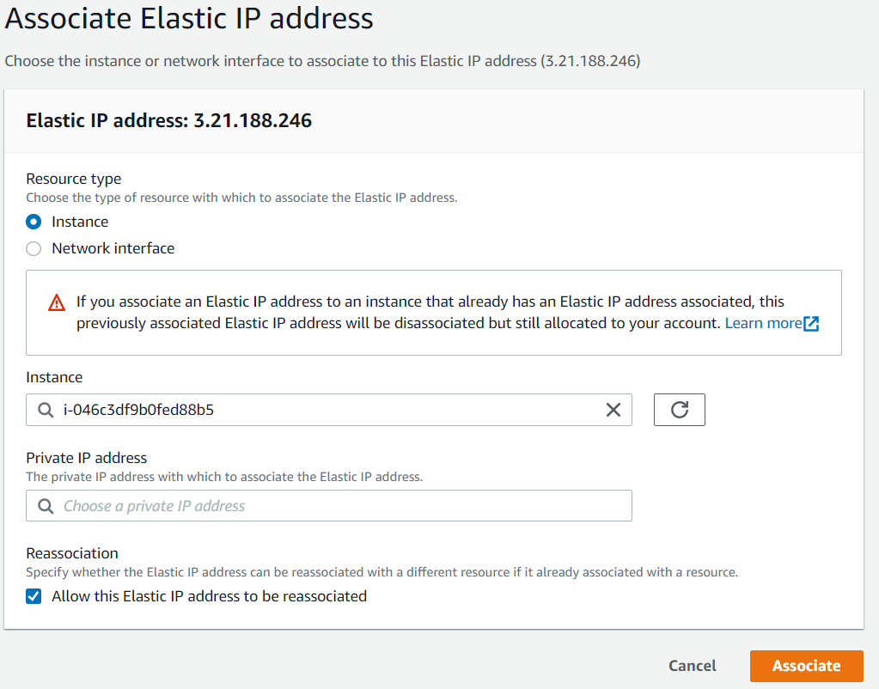

1. Elastic IP address associated successfully

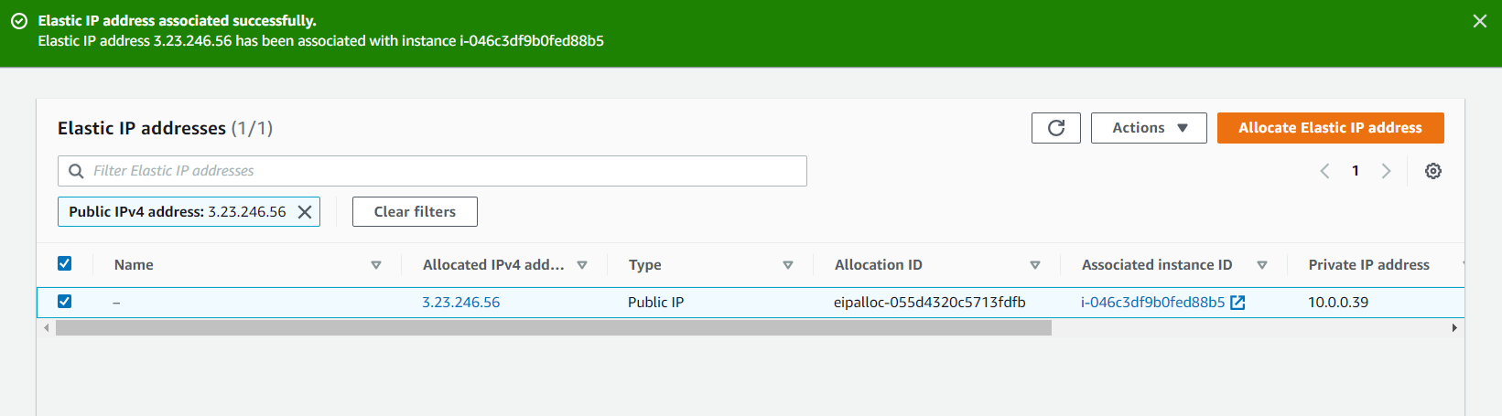

1. To associate the second server, create one more elastic IP

Click on “Allocate elastic IP address”

Click “allocate”

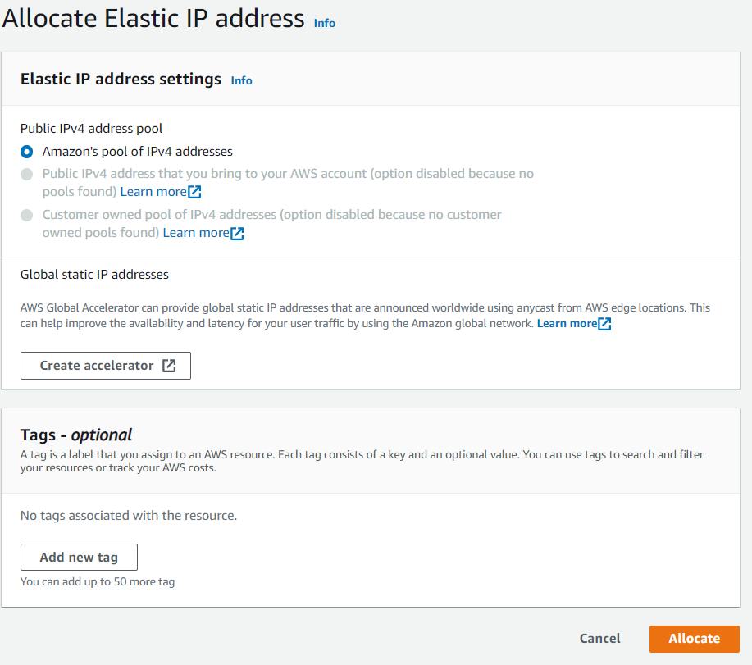

1. Second elastic IP has been created successfully

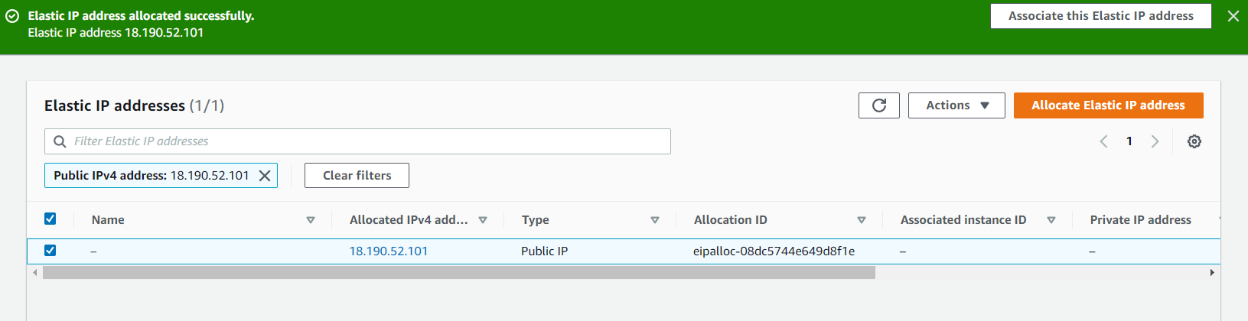

1. Check in and click “associate elastic IP address”.

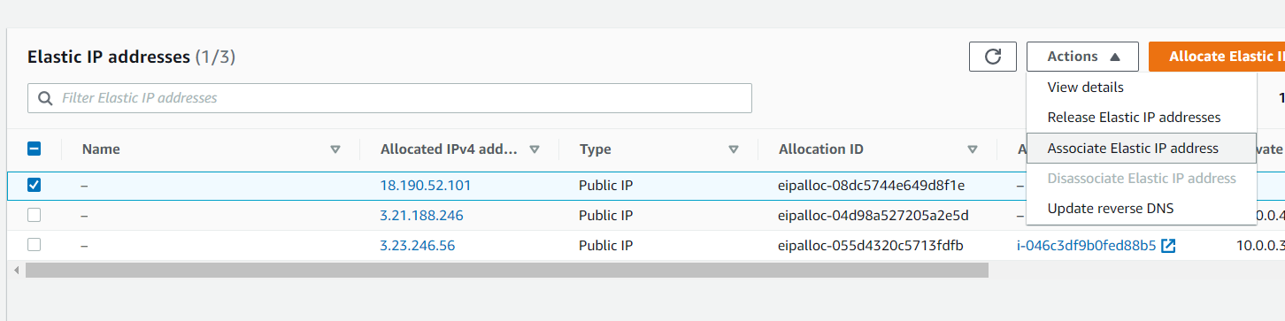

1. Select instance I2

Check in reassociation

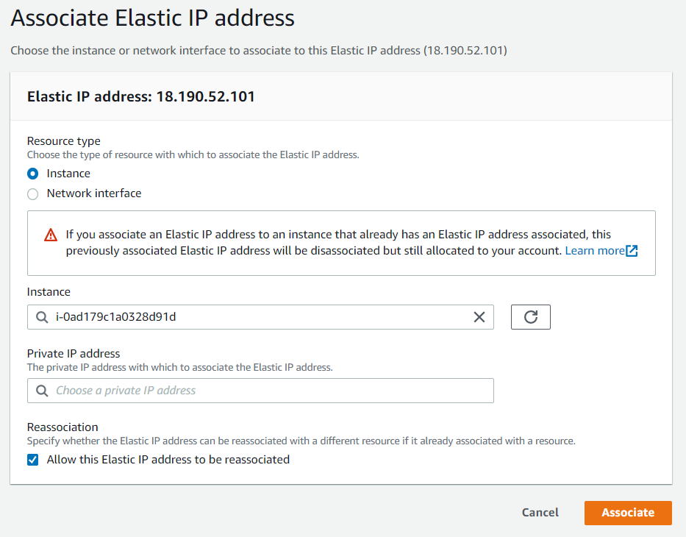

Click associate

1. So now we have created two elastic Ips for two instances. If the server stops the public IP will not change because of the elastic IP.



1. While hosting the web site the fixed IP is the better choice.
2. Connect the instance I1 from the local PC
3. Next we can create a “Load Balancer”

Click on load balancer

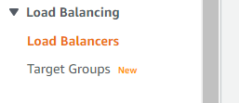

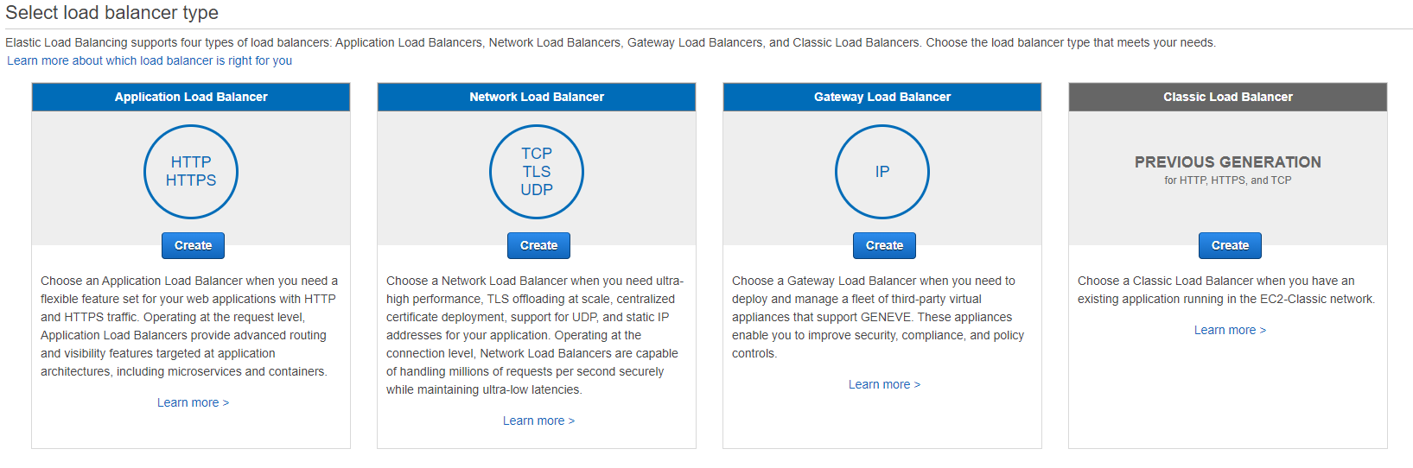

1. Now we are going create an application load balancer

Name it 🡪 myloadbalancer

Select the created VPC cloud and associate with the created public subnets.

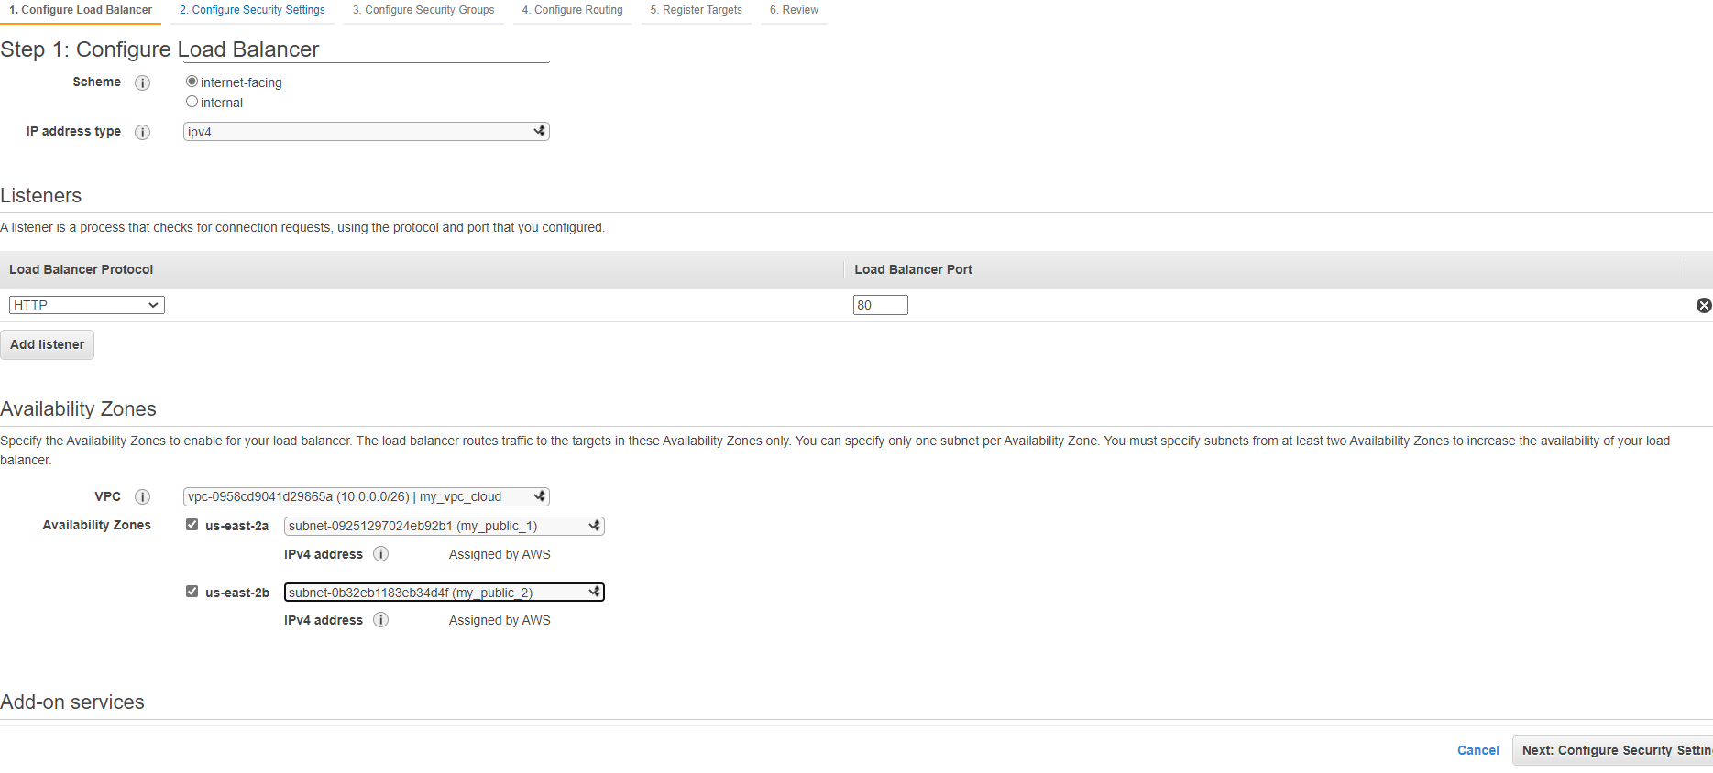

Click next

1. Click next to security groups

Create new security group.

Add rule of HTTP and HTTPS then only we can access the website.

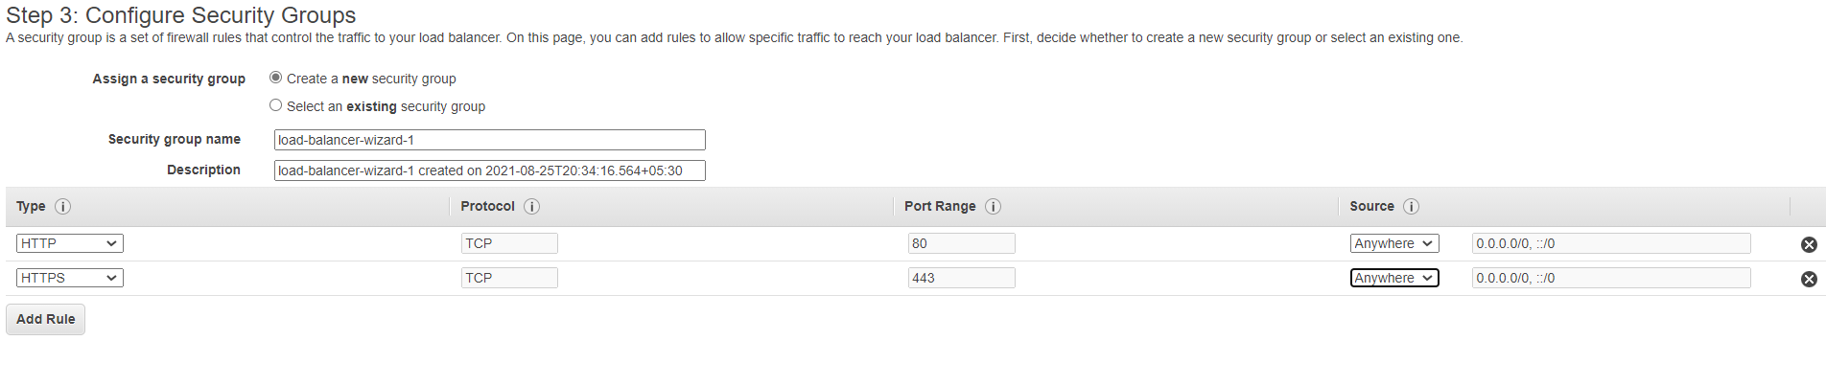

1. Configure Routing

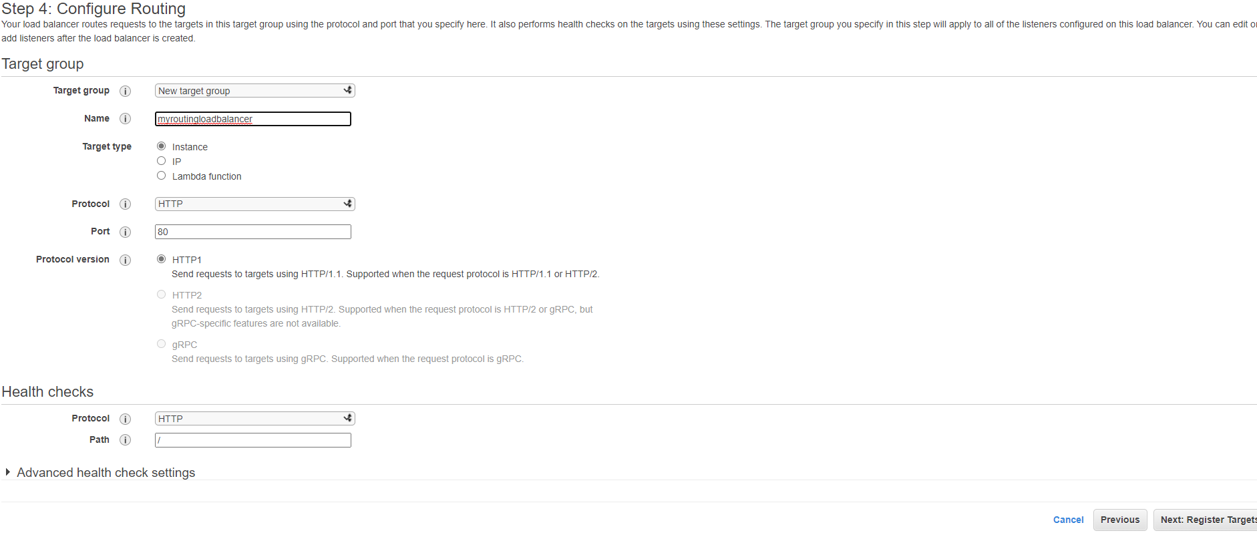

Click on to next

1. Register two instances I1 & I2

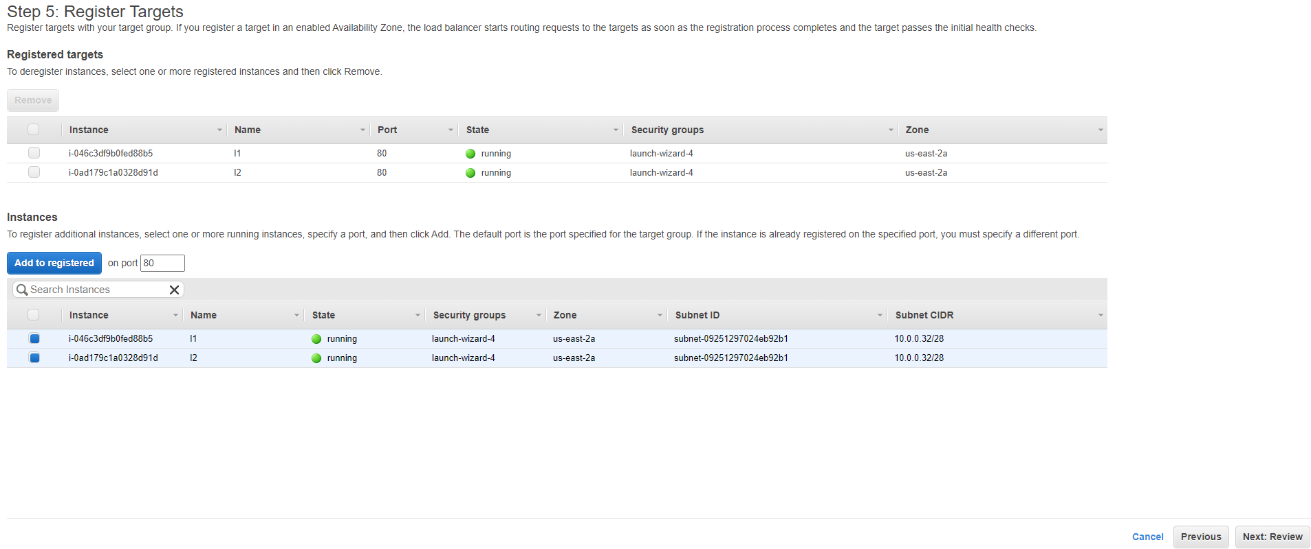

1. 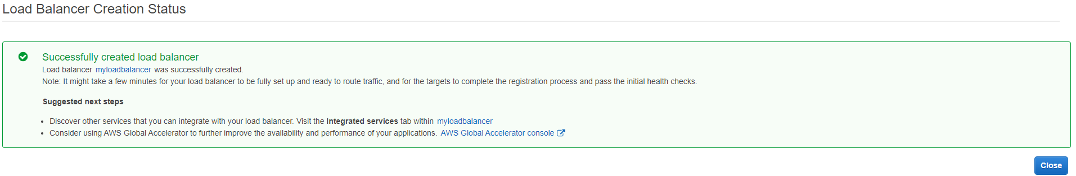

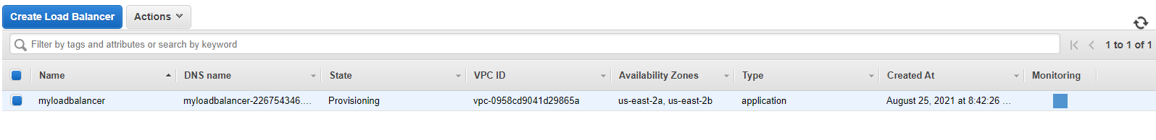

1. Go to the created windows instance and enter in to the ***server manager***. The only we can host the website.

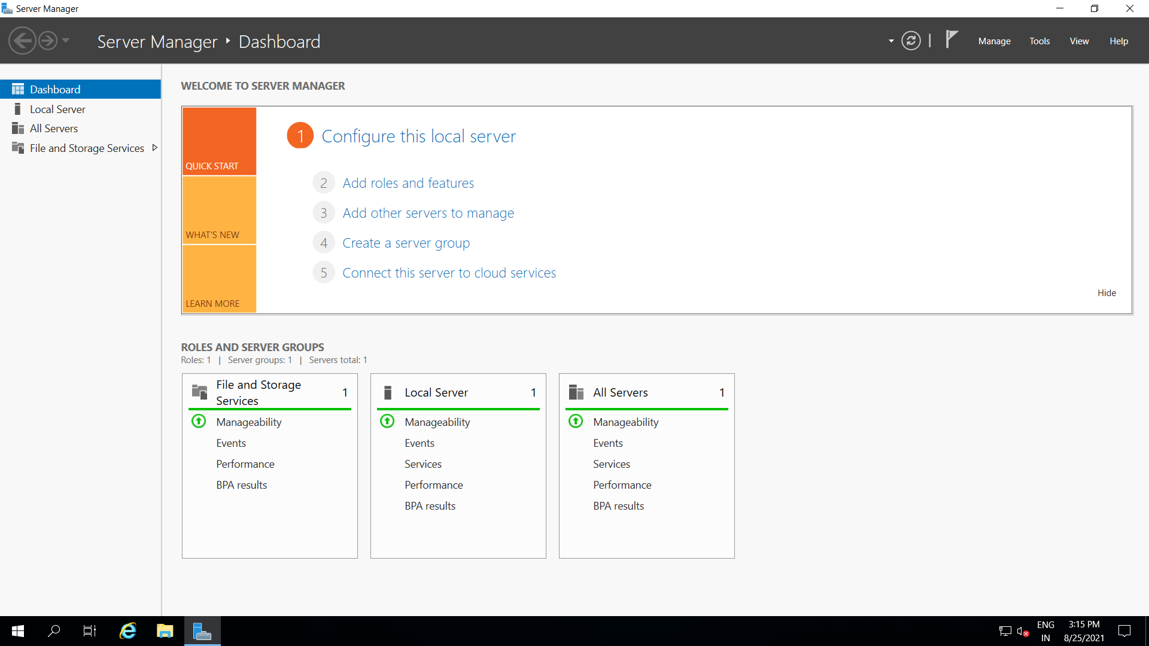

Click on Add roles and features

Add web server (IIS)

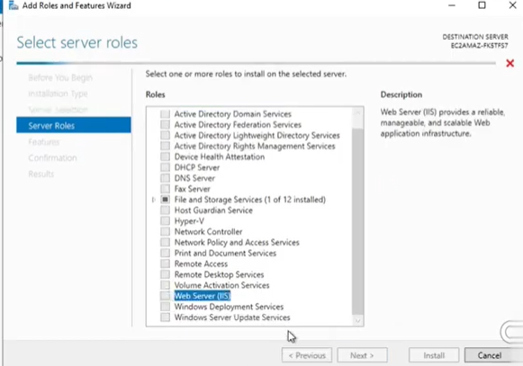

1. Create a sample html file in the local host of the instance I1

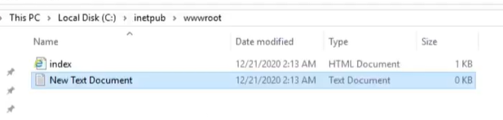

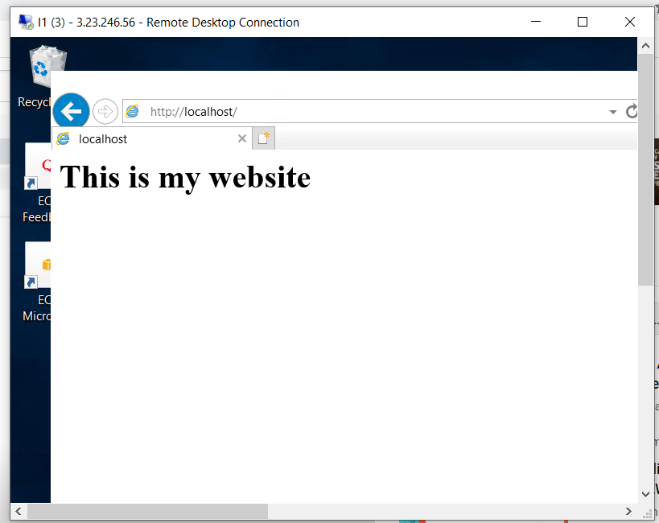

Copy the DNS address from the myloadbalancer details and search it on web.

myloadbalancer-226754346.us-east-2.elb.amazonaws.com

